**RIPHAH INTERNATIONAL UNIVERSITY, ISLAMABAD**



**Lab # 4**

**Task: 1**

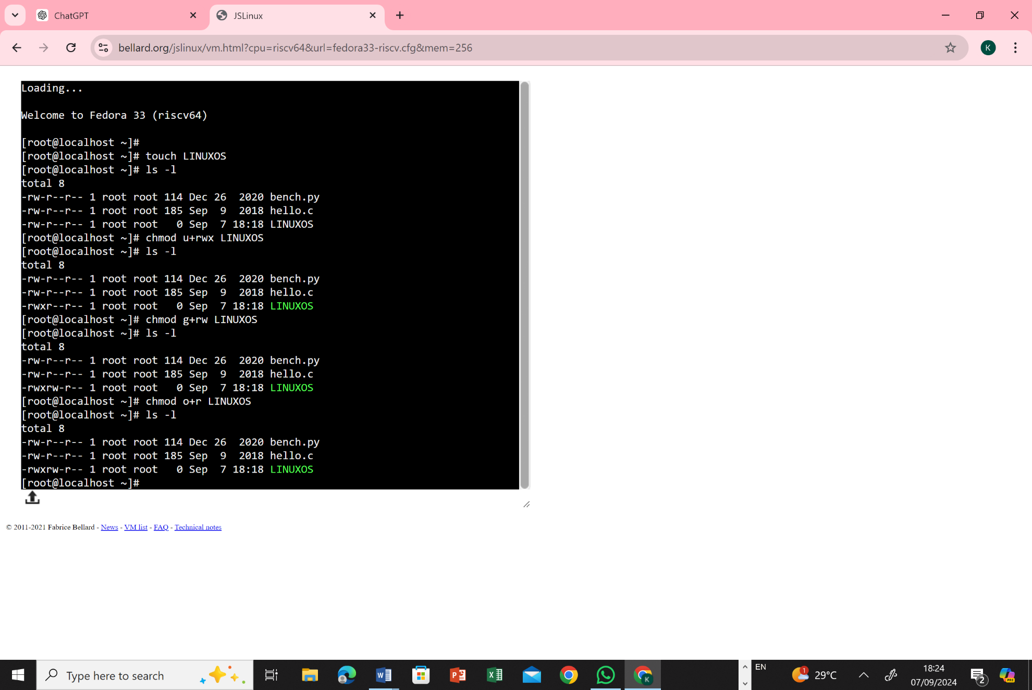

**Method 1: Using Numerical Method**

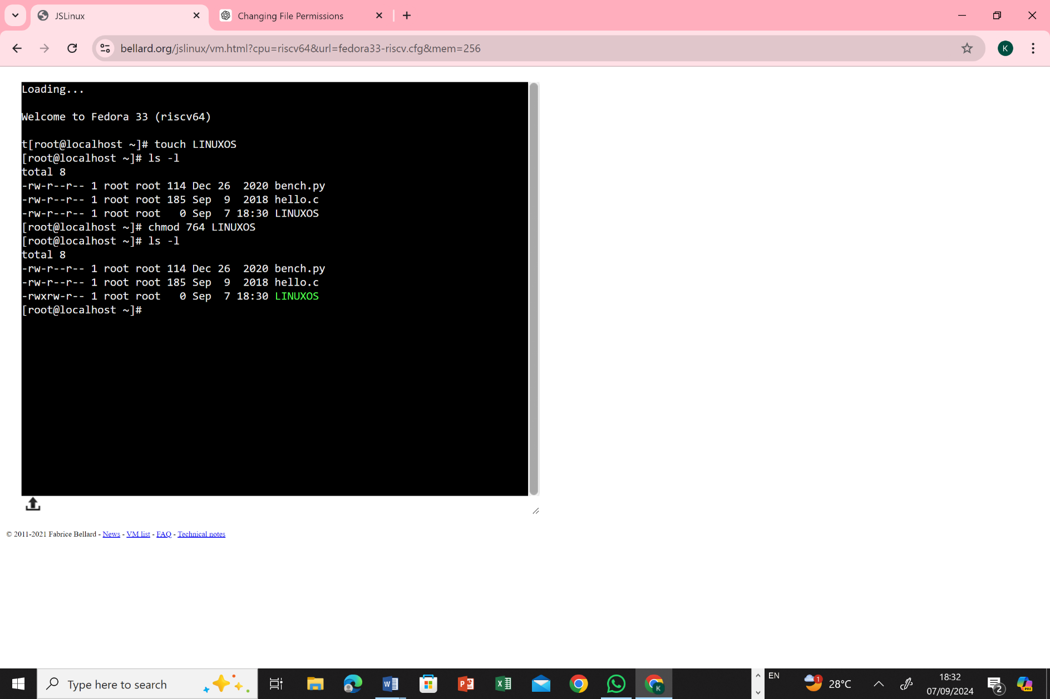

**Task: 2**

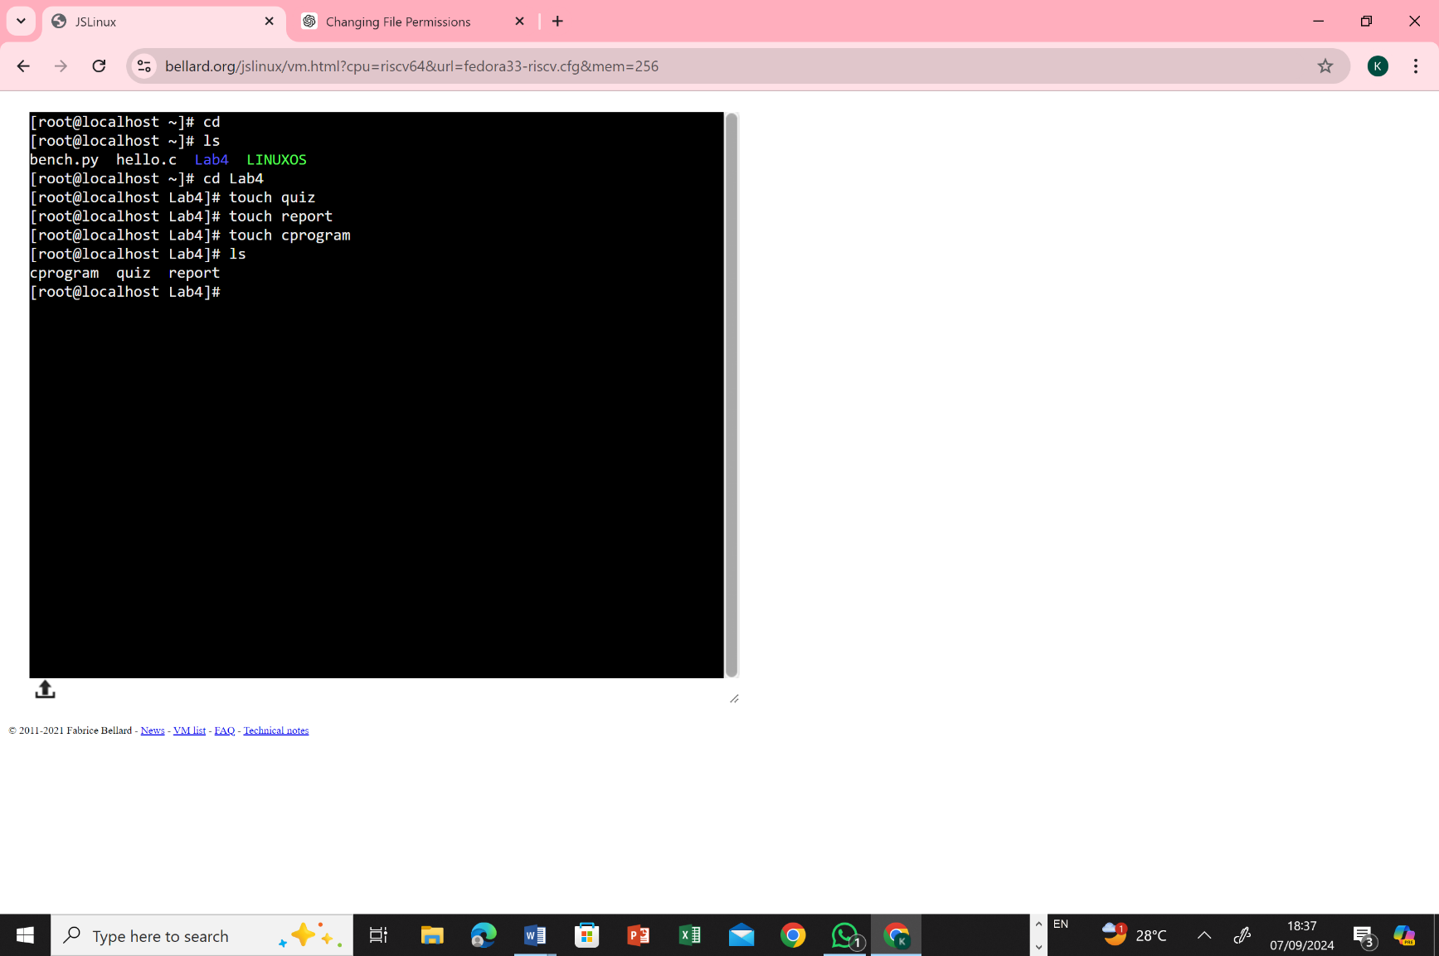

* **-rw-r- - r- - quiz**

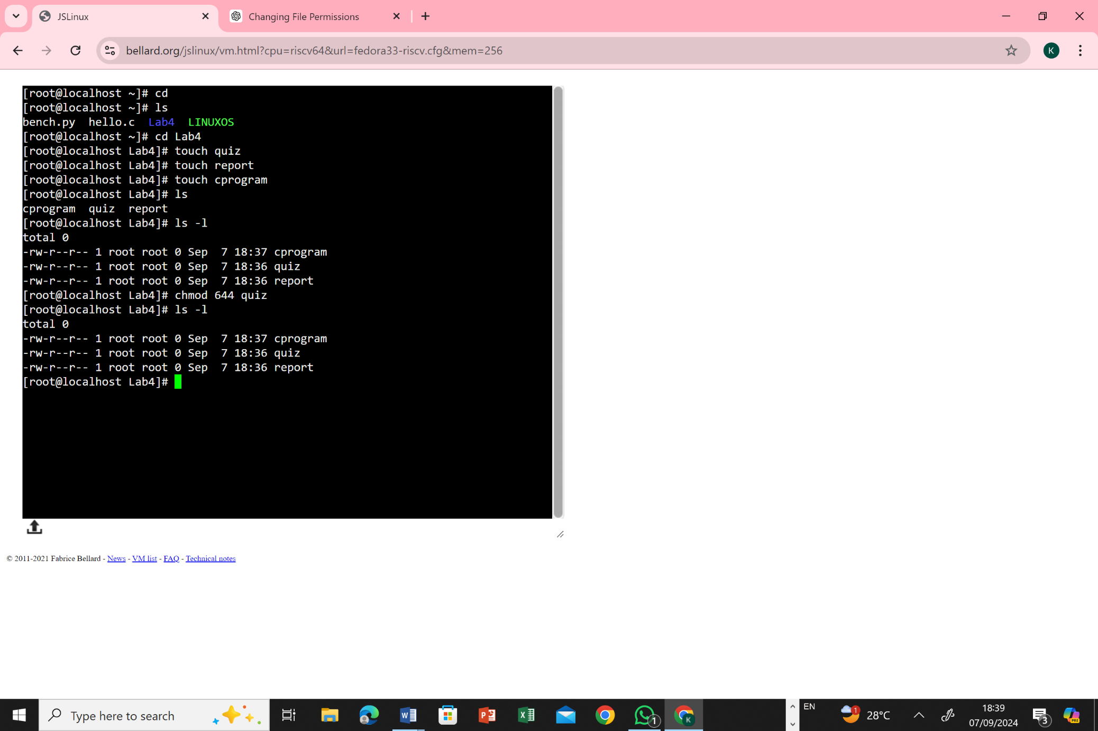

* 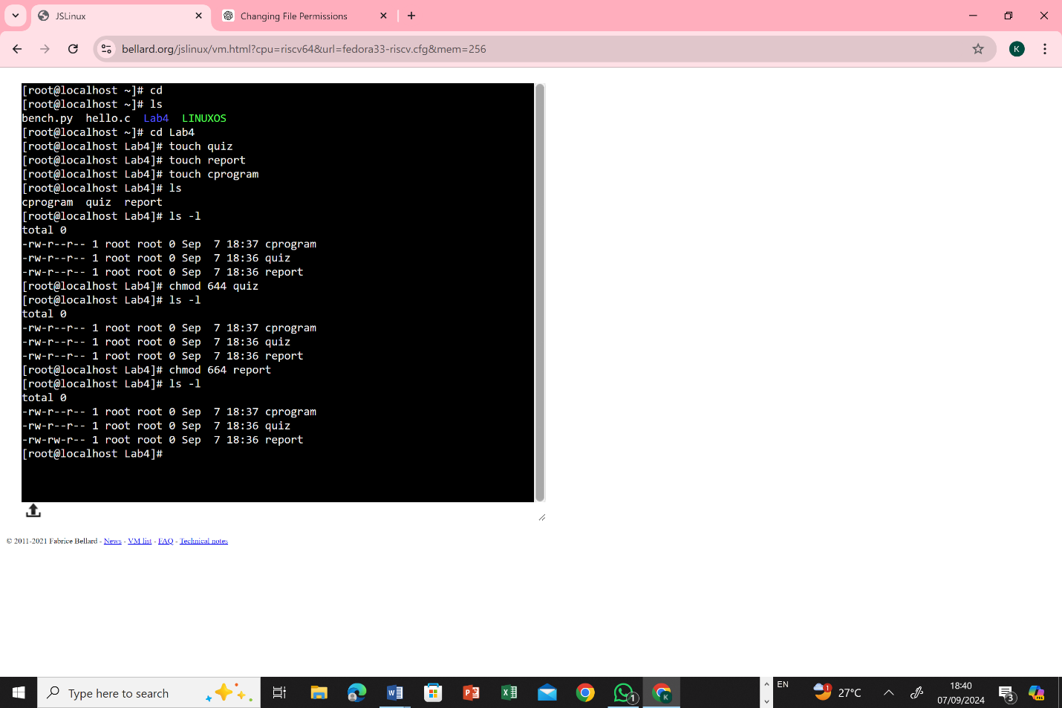**-rw-rw - r- - report**
* **-rwx rwx x cprogram**

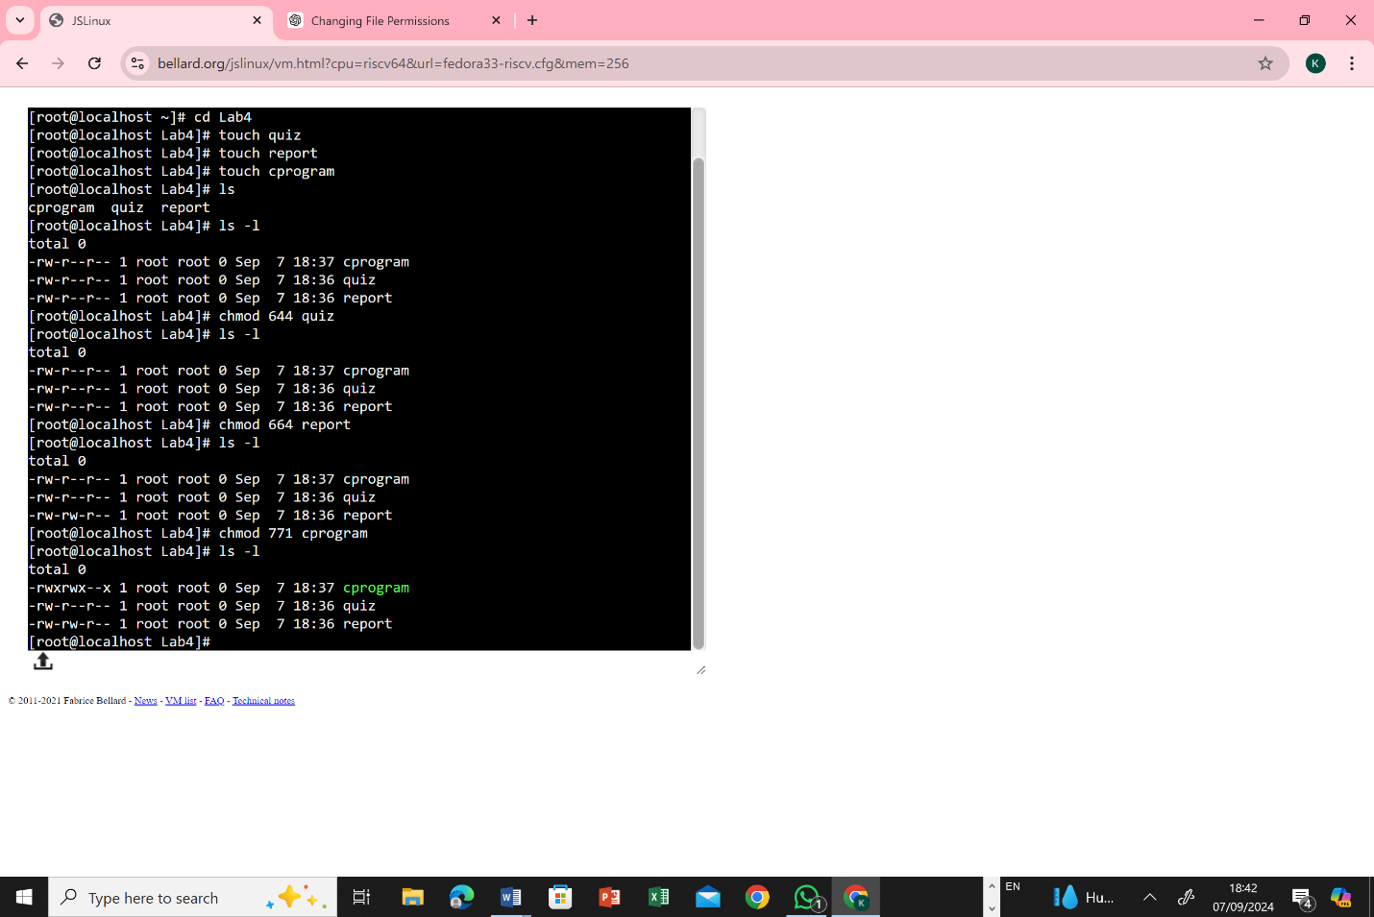

**Task: 3**

* On your Linux system, you have two directories named OSLAB and OSTheory.

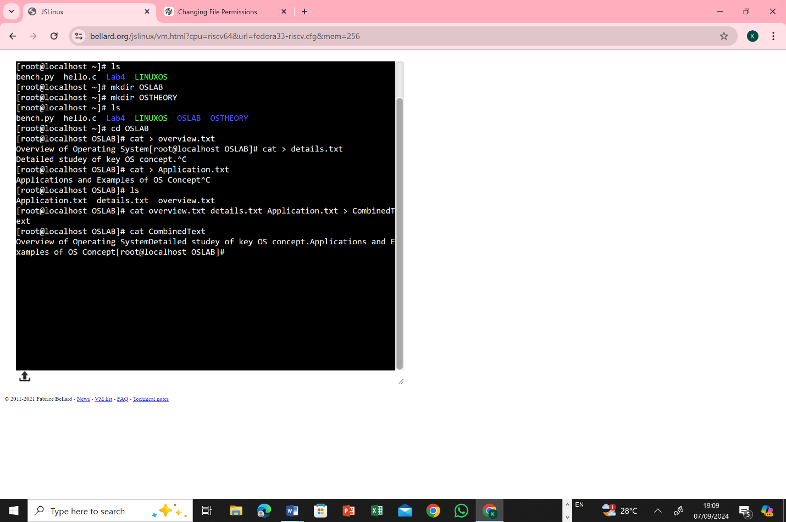

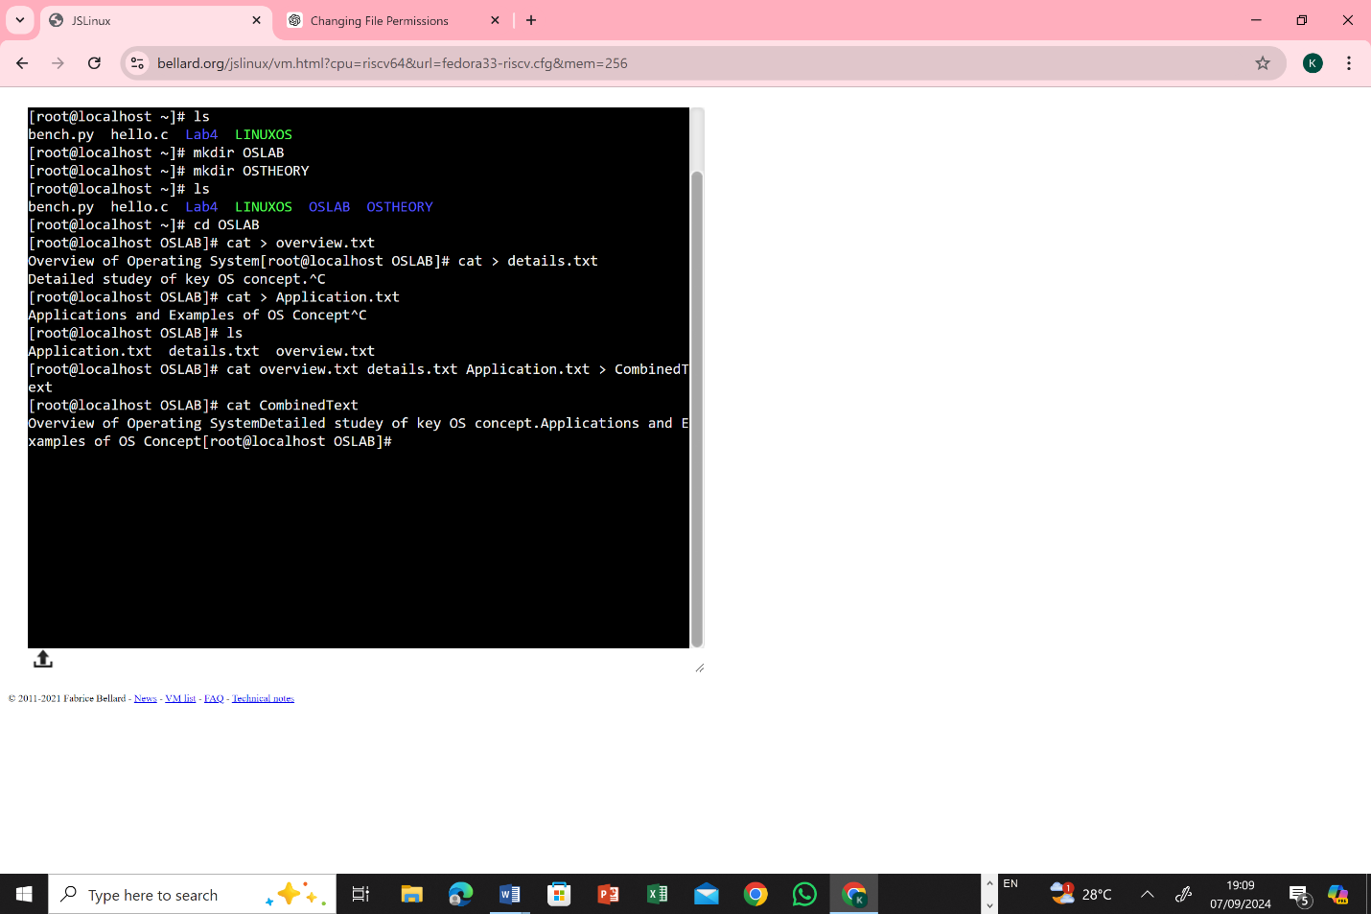



**Task: 4**

* Directory A contains at least two files named "FinalTerm" and "MidTerm". Directory B contains at least two files named "OSTheory" and "OSLAB".

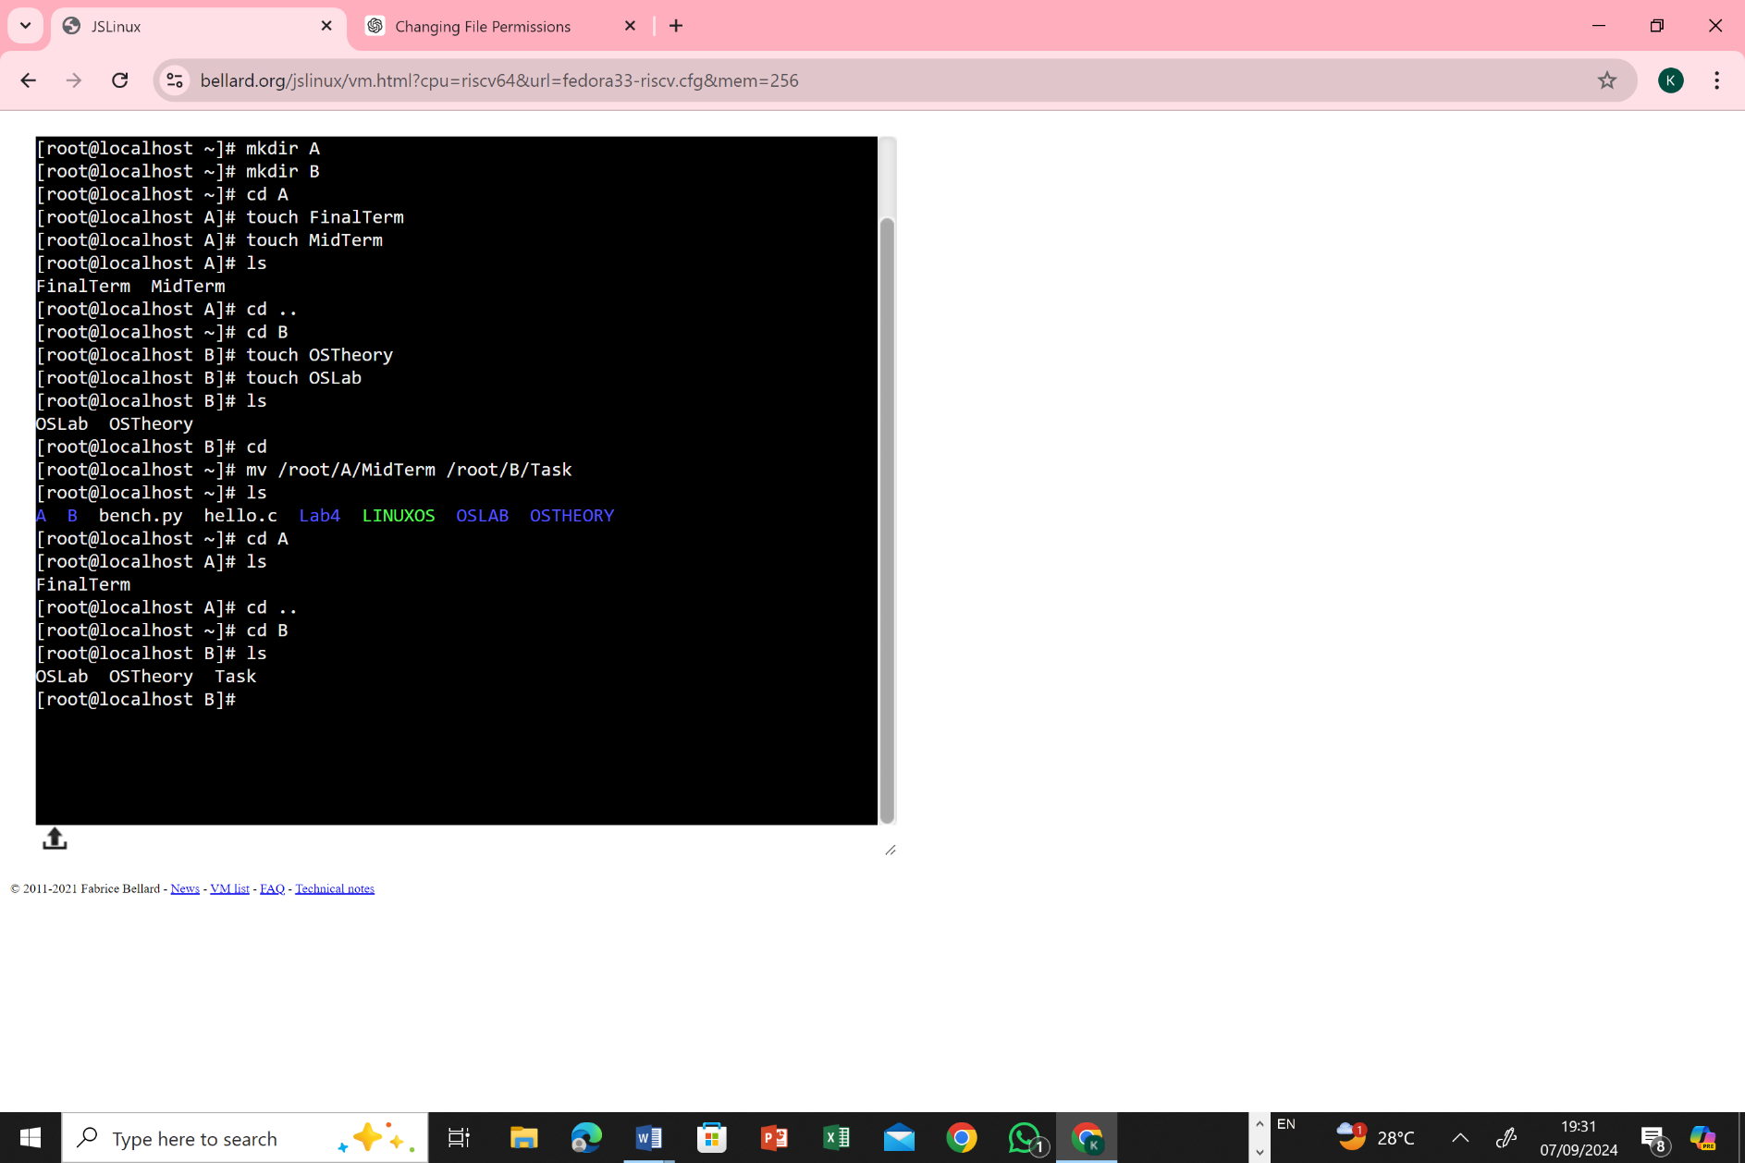

* Move the "MidTerm" file from the existing Directory to the Directory where the OSLAB file exists and Rename it with TASK.

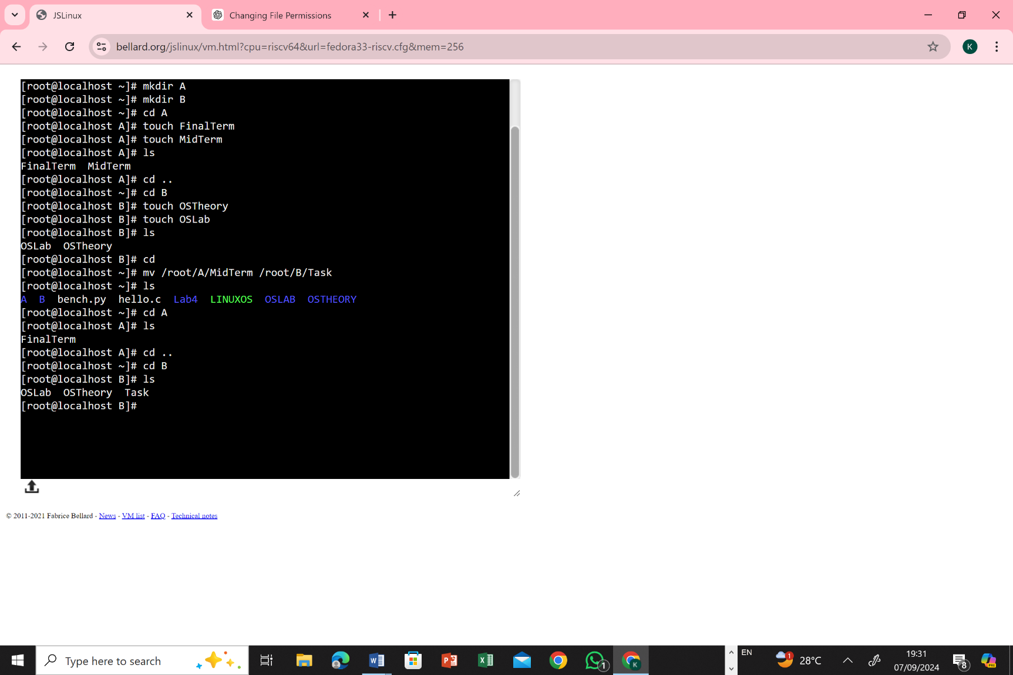

**Task: 5**

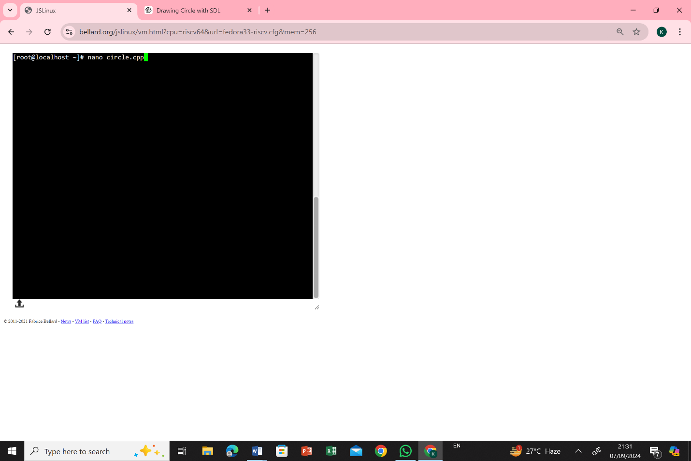

* 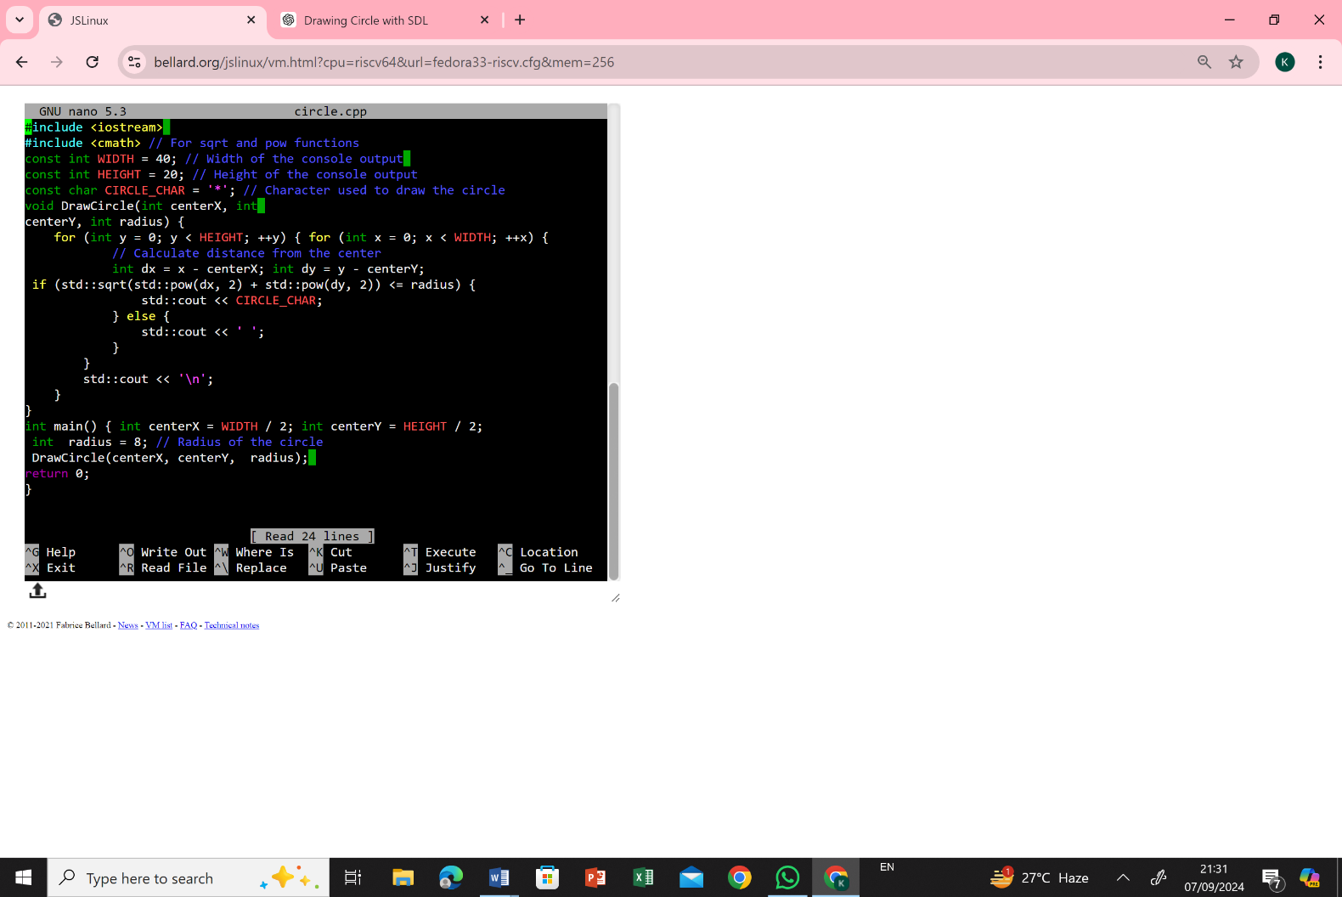writing the C++ code, compiling the program, and running it to display the circle.
* What commands and procedures would you use to accomplish this?

